5.1 System Analysis Phase
System analysis is the process of gathering information about current system, identifying its strength and problems and analyzing them to produce a new system (smart door access system).

5.1.1 System Abstract
System is centralized on managing the entrance of students to labs through the study year and controlling this entrance every day taking in consideration some criteria; also check all students' data.

5.1.2 System Request
Project name: Smart Door Access System.
Project Sponsor: Prof. Yousef B. Mahdy
Department: Management
E-mail: mahdy@aun.eun.eg
Business need:
- To have more control of labs entrance process.
Functionality:
- Making sure that the student met the conditions for entrance to
Labs such as barcode number, valid status, stage.
- Prevent unauthorized student from entering to the labs.
- To make the entrance more systematically.
- Decrease possibility of failure, theft, and destruction in labs.

Expected Value:
Tangible:
- avoid using mountain of papers that used in previous system
- reduce 30% of number of employee
- Decrease amount of money spent in computer hardware and software repair.
Intangible:
- Improved Students satisfaction.
- Reduced time consumption.
- Reduce possibility of error occurrence.
- Increase reliability of entrance process.
- Security accountability dimension will preserved.

Special issues or constraints:
- Project must be delivered within Study Year.
- budget for system
- Students may be not familiar with system or project
- users need two weeks at training
- program shouldn't cause any economic or physical damage in the event of system failure
5.1.3. Feasibility Analysis
Technical Feasibility : (Excellent)
- Familiarity with Application (Excellent):
Application consist of two sections
  - Software (Excellent):
- client server programs (high):
We had study network programming so we can develop robust client-server application.
- Database Administration (high):
We develop applications like this several times achieving before this project.
  - client with remote database connection (excellent) :
We have simple ideas about the remote connection with the Database.
    - hardware (low):
  - Dealing with external hardware in the project is limit such as barcode reader device, Parallel port interface, and external device connected to parallel port interface.
- Identifying to the barcode buffer data (moderate).
- How to get signal from parallel port (low).
2. Familiarity with Technology (high)
- C# 2005 (high)
- SQL 2000 (high)
- .Net sockets (high)
- Window API Functions (moderate)
- Project Size (Moderate):
  - The project is moderate size.
  - With some effort, we can design the system to be reliable & to be more efficiency thanks to new technology we use.
5.1.4 Cash Flow
 | 2008 (L.E) | 2009 (L.E) | 2010 (L.E) | 2011 (L.E) | 2012 (L.E) | Total (L.E)
Benefits
Save papers | 600 | 600 | 650 | 650 | 650 | 3150
Reduce employee | 11000 | 12000 | 11000 | 10000 | 10000 | 54000
Reduce Tools& Improved Services | 2000 | 2000 | 2000 | 2000 | 2000 | 8000
Total Benefits | 13600 | 14600 | 13650 | 11650 | 12650 | 65150
Development Cost
Server With Centrino Duo Processor | 5000 | 0 | 0 | 0 | 0 | 5000
Barcode Reader (for each lab) | 2250 | 0 | 0 | 0 | 0 | 2250
9 PCS @1,350 | 0 | 0 | 0 | 0 | 0 | 0
Network Cables | 0 | 0 | 0 | 0 | 0 | 0
Electronic doors (9 doors) | 900 | 0 | 0 | 0 | 0 | 900
Analysis & Designer Cost | 0 | 0 | 0 | 0 | 0 | 0
Programming Cost | 1000 | 0 | 0 | 0 | 0 | 1000
Total Development Cost | 9100 | 0 | 0 | 0 | 0 | 9100
Operational Cost
Hardware maintenance | 1000 | 1200 | 1200 | 1300 | 1400 | 6100
Software maintenance | 500 | 500 | 500 | 0 | 0 | 1500
Network Technician | 500 | 300 | 300 | 200 | 200 | 1500
Employee Training | 400 | 100 | 0 | 0 | 0 | 500
Total Operation Cost | 2400 | 2100 | 2000 | 1500 | 1600 | 9600
Total Cost | 11500 | 2100 | 2000 | 1500 | 1600 | 19700
Total | 2100 | 10500 | 11650 | 10150 | 11050 | 45450
ROI = Return On Investment
ROI = Total / Total Cost
=45450 / 19700 = 230.7%
NPV = Net Present Value
NPV = Total / (1 + Interest Rate) n
Where
- Interest rate equal 0.03 constant.
- N is number of years.
NPV = 45450 / (1+.03)5 = 52689.007
5.1.5 Developing a concept for the system to be build
We will develop the concept of the system to be build using process model. Process model is a formal way of representation how a business system operates. We will use data flow diagram to model the business process and the data pass among them.
5.1.5.1 Logical process model
Process model is a formal way of representing how the system operates. It illustrates the process or activities that are performed. The following figure (Context diagram) illustrate the system interact with its basic elements students and administrator.
5.1.5.1.1 Context diagram
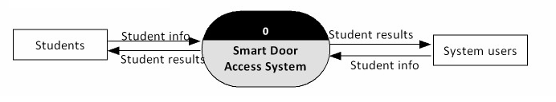
Figure (5.1): show context diagram of system.
5.1.5.1.2 Level 0 Diagram
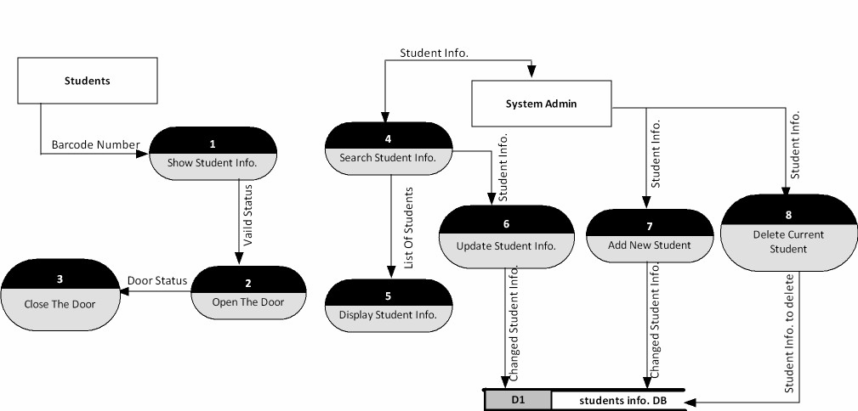
Figure (5.2): show Level 0 diagram of system.
5.1.5.1.3 Level 1 Diagrams
Fig (5.3), (5.4) shows level 1 of the open door process and show student info
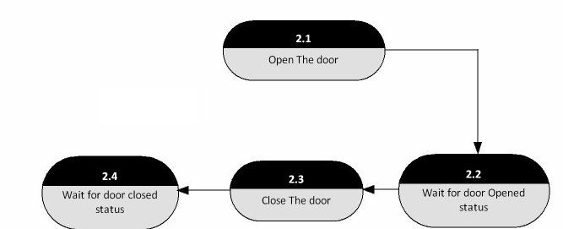
Figure (5.3): Open Door Level 1 diagram of system.
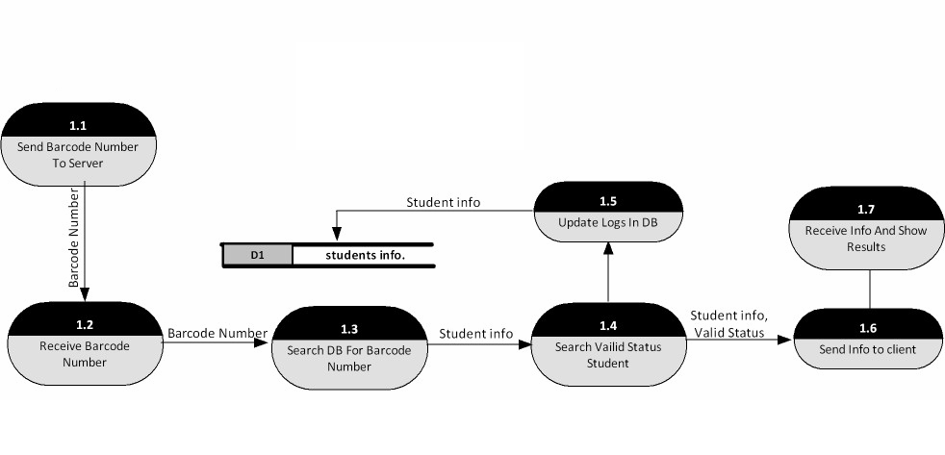
Figure (5.4): Show Student info Level 1 diagram.
5.2 Database design
When we talk about database we are really talking g about the most important part in the project. Database is the backbone of the project it's where we store information. Now we will view the database showing its tables and attributes in details.
5.2.1 Database tables
- AdminUsers
- Doors
- Logs
- ServerSettings
- Users
- Users_Doors

      - Adminusers table Fig (5.5)
This table contains attributes that indicates information about the admin that control the entrance of the students to the labs.
Name: indicate the name of the admin and represent the primary key of the table.
Password: indicate the password of the admin for administration.
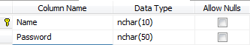

Figure (5.5): show Adminusers table structure used for login process.
      - Doors table Fig (5.6)
This is another table in the database that contains information about the doors of the labs that will connect to the server.
doorNum: door number - primary key for this table.
doorName: indicate the name of the door.
doorLastLogRecieved: indicate when did the client send a log of events for the last time.
doorLastListUpdate: when did the server send a list of allowed students for the last time
doorIP: IP address of the client computer.
doorPassword: password that the client must provide on every connection.
doorMAC: MAC address of the client computer's network card (not used).
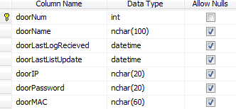

Figure (5.6): show Doors Table structure
      - Logs table Fig (5.7)
"Log of events – every card reading is an event"
This table indicates information about the logs that happen during entrance.
Enter_time: indicate date and time of the event and represent the primary key.
ID: indicate user card number and also this attribute represent the primary key.
doorNumber: indicate door number and also this represent the primary key.
Allowed: indicate whether the student was allowed to enter.
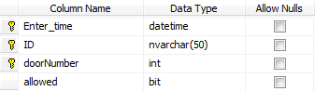

Figure (5.7): show Log Table Structure

      - Server Settings table Fig(5.8)
This table's attribute provide information about the server.

Name: this attribute indicate setting name and represent the primary key.
Value: this attribute indicate setting value.
Description: this attribute indicate string – not used.
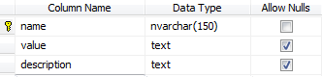

Figure (5.8): show ServerSettings table structure
      - Users table Fig (5.9)
This table provides information about the users – students who are registered to the system.
userID: number of the user's ID card or any other card he uses to enter the lab.
userfName: indicate the first name of the student.
userlName: also this indicate the last name of the student.
userValid: indicate whether the user is active or not.
userEmail: indicate the email address of the student.
userPhone: indicate the phone number of the student.
userDescription: Indicate description that write about the student.
userStage: indicate the stage of the student.
userImage: contain the image of the student.
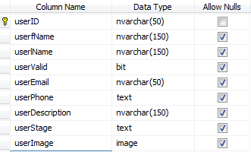

Figure (5.9): show Users Table Structure

      - Users_Doors table Fig (5.10)
This table contains attributes that connect between user table and door tables.
userID: indicate number of the user's ID card or any other card he uses to enter the lab.
doorNum: indicate door number - primary key for this table.
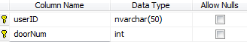

Figure (5.10): show Users_Doors Table Structure
5.3 Entity Relationship Diagram (ERD)
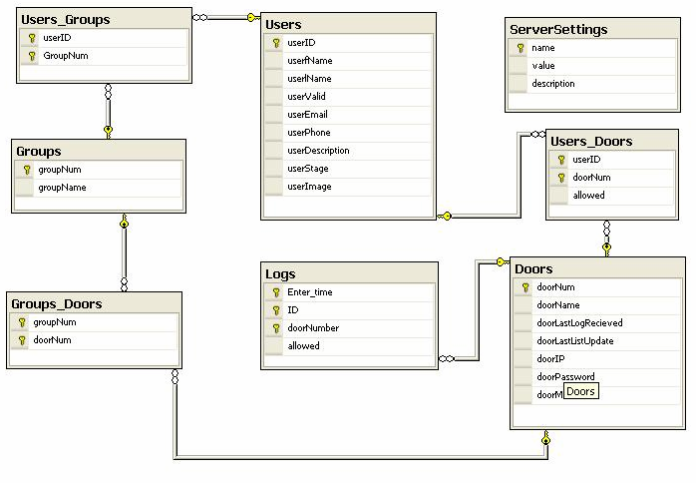
This ERD Model in Fig (5.11) describes the tables and its relationships among them.
Figure (5.11): show ERD Diagram of system
5.4 Database Administration
This section will illustrate the interface of the DB admin side, Fig (5.12) show design interface of the Database administration.
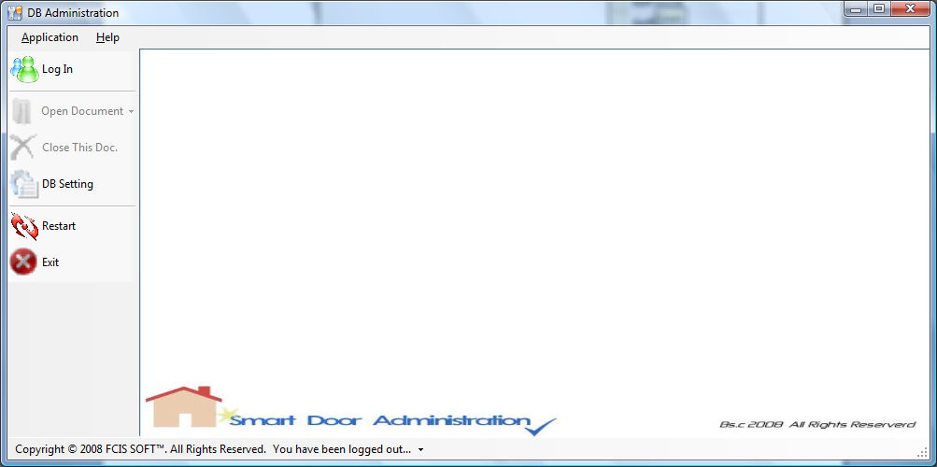
Figure (5.12): show design interface of db admin side.
If you select Log in menu item, the below form (Log In) will appear, so if there is already admin user exist, just choose "log in" radio button otherwise choose "new account" and then press "OK" as shown in Fig (5.13).
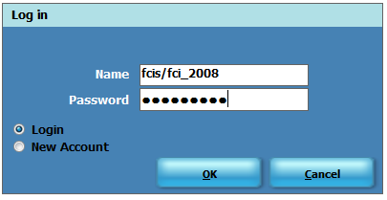
Figure (5.13): show design interface of db login form.
After the admin choose "log in" then it has some capability such as open document of (students, doors, logs, server setting) detail sheets, close doc, DB setting, restart and finally close this application as shown in Fig (5.14). But if the admin choose "new account" the application allows him to enter his information through the same form and then message will appear in application status bar say "Account has been created, please login" appear.
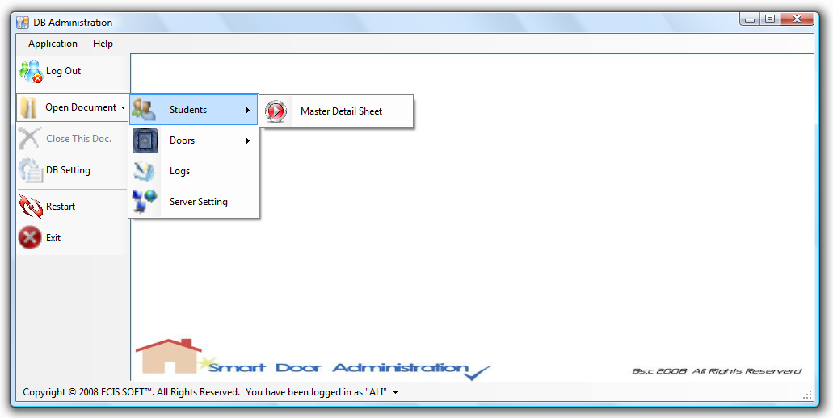
Figure (5.14): show Capabilities of db admin users.
If the admin user choose open document for "student", and then choose master detail sheet, he can change the student's data as show in the Fig (5.15) and then save the change also he/she can add new data, delete data, search about data and also he can change the image by import another one.
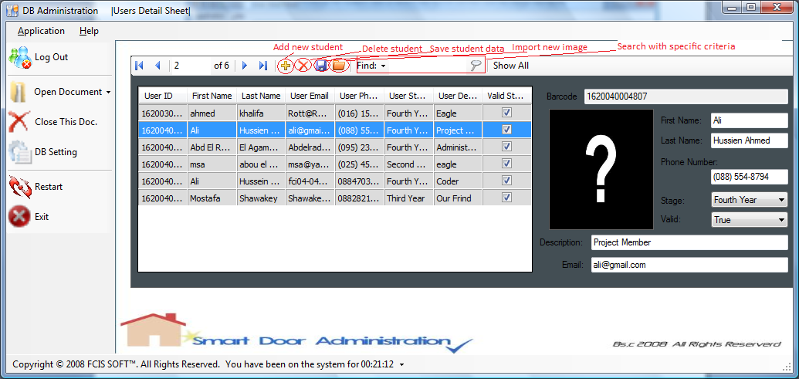
Figure (5.15): show student data form to insert, update and delete.

If the admin user want to change in the door's data just follow this steps in Fig (5.16).
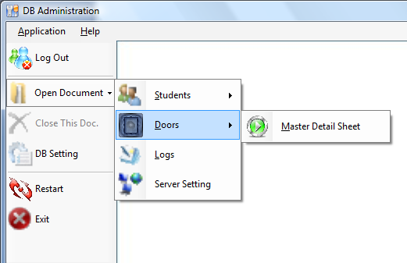
Figure (5.16): show steps followed to show doors information.
After the admin do these steps this form will appear and he can do what he wants such as add, update, delete, and search for doors data and he/she can assign any student to be access granted/denied over specific door as shown in Fig(5.17).
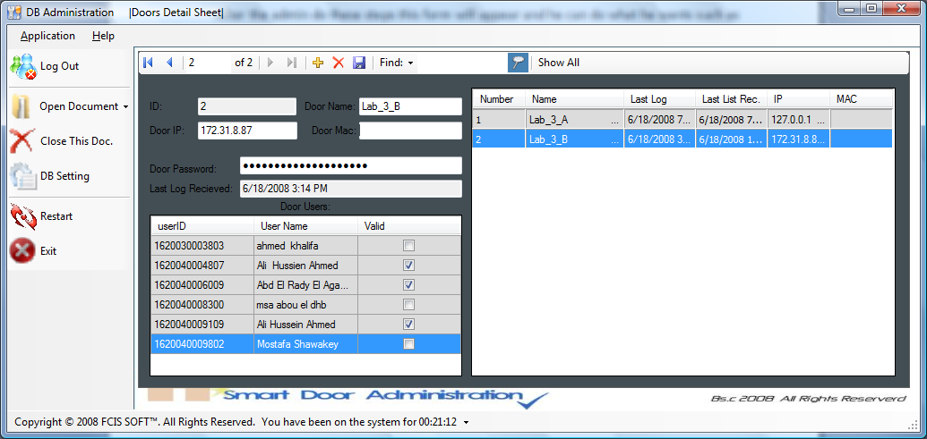
Figure (5.17): show Doors info to update.
Just note here that if admin user wants to close any form he has to click the middle left menu item named "Close This Doc.".
Also admin user can Show logs Detail sheet as shown in Fig (5.18).
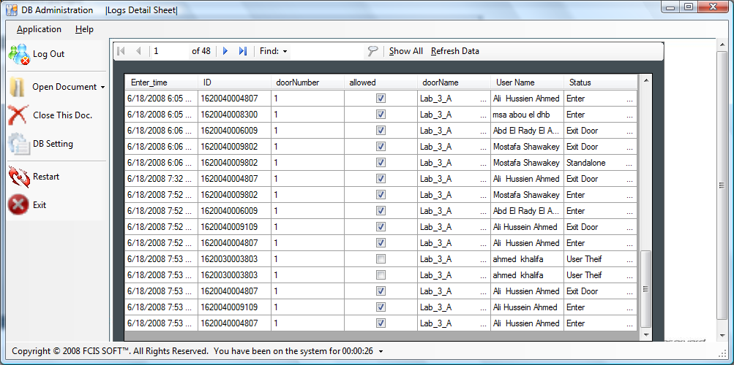
Figure (5.18): show logs information sheet.
The last the capability user can achieve is to edit in the "server setting" and this can do with these steps (open Document--⇨server setting) and form in Fig (5.19) will appear also the admin can add new Configuration details, delete any Rows and search about any data in this form.
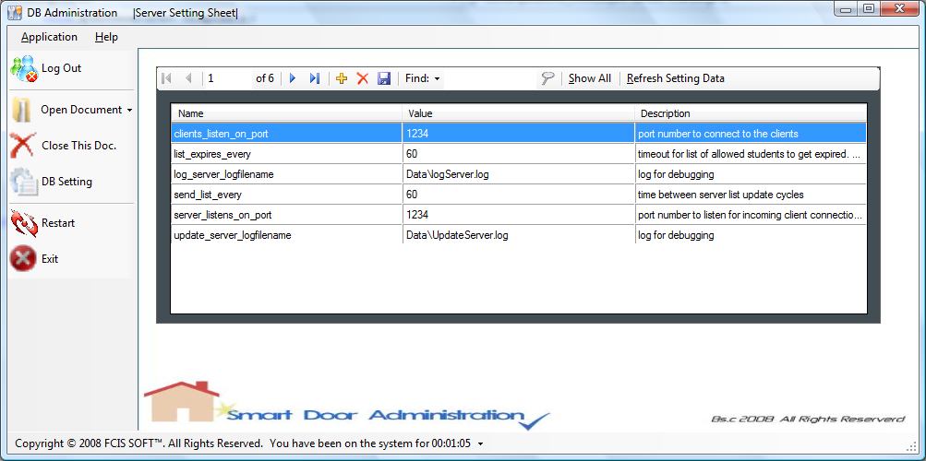
Figure (5.19): show Server Setting configuration form.
Last note here there is DB Admin Configuration form as shown in Fig (5.20), so this application can work also on a remote database by just change name of computer device where system database is located.
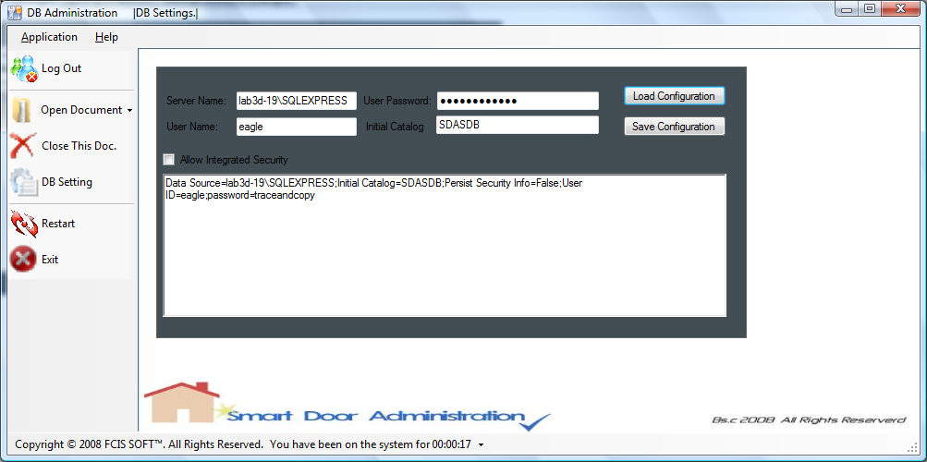
Figure (5.20): show DB Setting configuration form.

